ComSci 490U Introduction to UX Research
Instructor: Cindy Xiong
Factorial Design Worksheet (Assignment 4)

Due: Friday, March 24th

Your Name: _________________________________ Score ________________________/38
#1 You are designing a food delivery app and you have 5 designs to test out: Designs A, B, C, D, and E. Your manager gave you a budget to cover the cost of 5 participants. How might you design your experiment to test all 5 designs… (10 points)

- via a Between-Subject experiment?

- via a Within-Subject experiment that minimizes order effects, learning effects, and carry-over effects?

#2 Your co-worker in engineering created 3 prototypes of a hand-held device: one with a touch screen made with a light-weight material, and one without a touch screen and it is also made with a light-weight material. The third one is also without a touch screen and is made of a heavy-weight material. Having learned about experimental design in class, you realize that your co-worker should have designed a 4th prototype. What feature(s) should that 4th prototype have? (2 points)

#3 You want to investigate the effect of two website design ideas (simple modern vs retro) displayed using different devices (Mobile, Tablet, Desktop) on website text readability. What does a factorial design for this experiment look like? (8 points)

- Fill in the blank. This experiment will be a ____ x ____ factorial design.

- Fill in the blank. There will be _____ conditions.

- List the condition(s) below.

#4 The data scientist in your team created this chart based on the user data you collected. Interpret this result by stating the effect size of the correlation (small, medium, or large) and the direction of the correlation (positive or negative). Also describe the results in plain English so the stakeholders in your team with no background in statistics will also understand. (6 points)
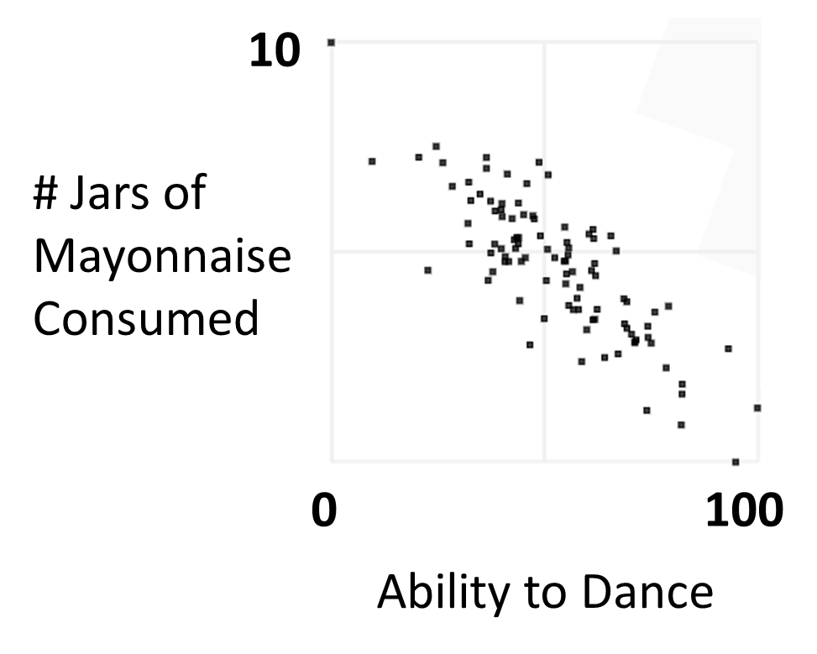

There is a _________ (positive, negative), _______ (small, medium, or large) correlation between ___________________________________ and ___________________________________,
such that ______________________________________________________________________
______________________________________________________________________________
_____________________________________________________________________________.
#5 Your team is investigating the usability of an app on tablet versus desktop and recruited both experts and novices to use it. The previous UX Researcher on this project left the following charts behind without documenting what happened. Your good friend in marketing wants to make use of these results but is not sure what is happening. Describe the main effects and interactions in the data in plain English so they can understand. (6 points)

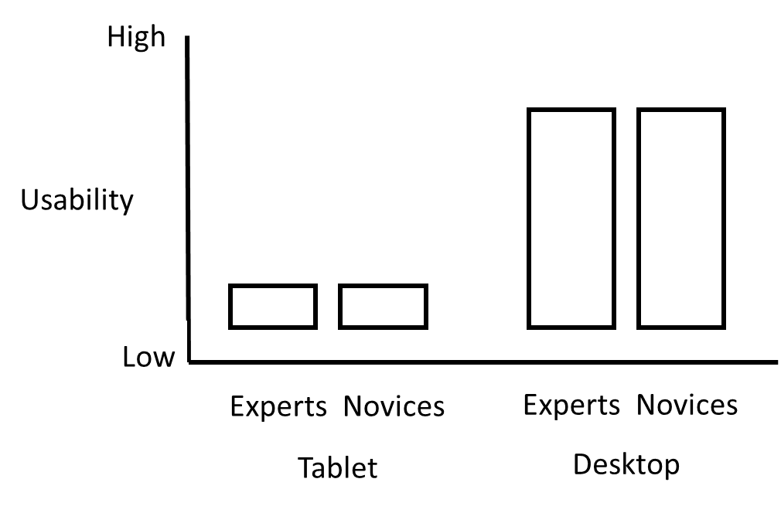

- Is there a main effect of device (tablet vs. desktop)? Why or why not?

- Is there a main effect of user expertise (expert vs. novice)? Why or why not?

- Is there an interaction between user expertise and device? Why or why not?

#6 You found an updated version of the result on usability of the app. The data looked different. You didn’t want your friend in marketing to act with outdated data, so you rush over with a new set of interpretations. (6 points)
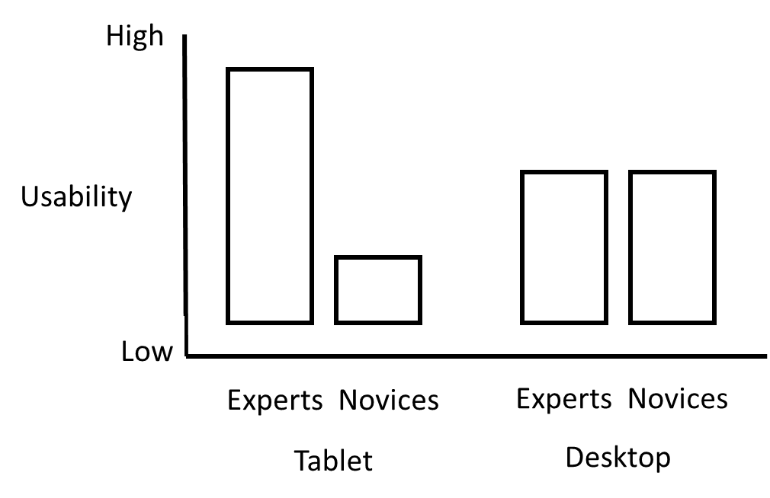
- Is there a main effect of device (tablet vs. desktop)? Why or why not?

- Is there a main effect of user expertise (expert vs. novice)? Why or why not?

- Is there an interaction between user expertise and device? Why or why not?

# 7 Bonus Question (1 point) Say one nice thing about Professor Xiong or TA Aimen or one of your project group members.

